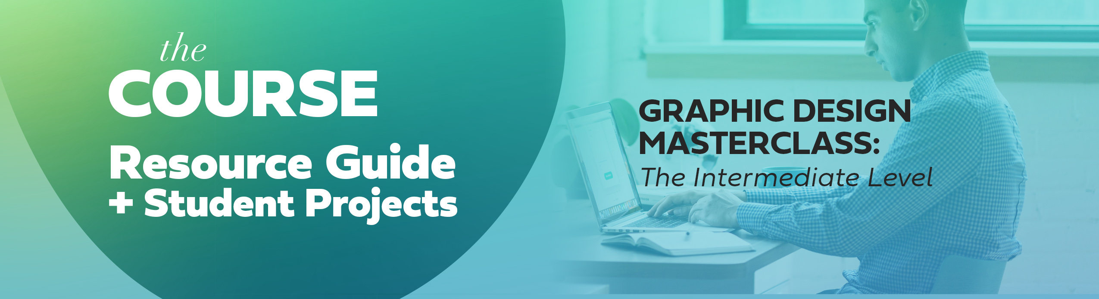
Welcome to the course!
This document gives you a course breakdown and is a basic outline of what to expect in the course including: Student projects, section descriptions and when you can skip ahead to certain sections.
Feb 2020 - Big Updates Coming
Big updates are coming to this course. You may have noticed the first section of the course has already been updated to the latest Photoshop 2020. Also, a new burger ad design project as been added. The logo design section will also get new updates in Feb 2020, so stay tuned, I will let you know when new updates are ready to be viewed. Also a new Portfolio building section has just been added as well as a new intermediate indesign Magazine Cover project! I will continue to list new updates here as they come. Feb 5th 2020, I just loaded a new Isometric design section after the logo design section.

Course Introduction Section
That is the section you are in now. The course guide video is helpful in giving you a visual based walkthrough of what to expect in the course.
Included below are links to all of the mock-ups, photos and resources I use throughout the class. Most Pexels.com photos are totally free to use, but do read any copyright information on anything you download to know your usage rights. Any mock-up from graphicburger.com is mostly free to use, always double check before downloading.
Please let me know if you cannot locate a graphic or resource, I will be happy to add it to the list or find an alternative for you.
(NEW) Photoshop Intermediate Techniques
We start off the course reviewing some more intermediate techniques in Adobe Photoshop including covering the content aware options as well as building a realistic composite photo and learning more about curves, shadows, lighting and more.
We will cover:
Content Aware Tool
Perspective Warp
Content Aware Practice
Building a Photo Composite using two different photos
Curves
Photos used during this section (Content Aware Portion)
Woman standing up - clouds
https://www.pexels.com/photo/woman-in-white-long-sleeved-top-and-green-skirt-standing-outdoors-3552544/

Windows
https://www.pexels.com/photo/white-painted-wall-3499125/

Stripes on street
https://www.pexels.com/photo/man-wearing-yellow-jacket-3490253/

Squares
https://www.pexels.com/search/woman/

Grass
https://www.pexels.com/photo/autumn-dried-leaf-field-garden-289613/

Woman on Stairs
https://www.pexels.com/photo/woman-standing-on-gray-concrete-stairs-1329808/

STUDENT PROJECT - Create your own photo composite
Your challenge for this section is to take two totally different photos (for an added challenge, photos with different color and lighting) and combine them together to create your own unique photo composite. Also, feel free to practice with the photos used in the course below.

Creating a Photo Composite (Door/Ocean Photo Manipulation)
Door & sky
https://www.pexels.com/photo/window-view-of-sea-during-golden-hour-2733955/

Woman walking on the beach
https://www.pexels.com/photo/photo-of-woman-walking-on-seashore-2072583/

Creating Realistic Shadows in Photoshop
In this extra section we will review how to create and paint on realistic shadows using the paint brush tool in photoshop. This skill will come in handy as we work through several projects later on in the course.

Photos used in this section
Coffee Cup
I cannot locate the same one I used during the video lesson but there are several great options to download for practice that are very similar to the one I used, see link below.
https://www.pexels.com/search/coffee%20cup%20/

Pink Flower
https://www.pexels.com/photo/photo-of-pink-rose-on-white-surface-929778/

Phone Graphic
https://www.pexels.com/photo/gold-iphone-6-with-note-pads-744464/

(NEW) Creating a Full Page Ad for a Fast Food Company
We will work through the process of creating a full page ad to advertise a new burger from a fast food company.

We will cover:
Layout an Blocking of an Ad
Creating Dynamic Movement with Type
Complex Layer Styles
Adding Effects to Type
Photo Editing for Food
Converting RBG to CYMK and retaining vibrant color

Downloadable Resource (Photoshop Template)
There is a downloadable template that contains the basic size for the full page ad we will be working on in the course.

Photos used during this section
Hamburger
https://www.pexels.com/photo/close-up-photo-of-a-cheese-burger-1633578/

Fire
https://www.pexels.com/photo/photograph-of-a-burning-fire-672636/

Dew
https://www.pexels.com/photo/macro-shot-photography-of-water-drops-1028600/

STUDENT PROJECT - Create a fast food full page ad
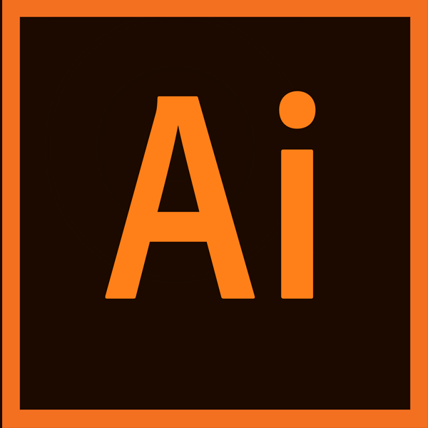
Your challenge for this section is the create your own fast food ad. I am looking for something that puts a big focus on the food being advertised with a bold compelling headline that can work great in digital ads and in print ads. No need for a ton of typography on this ad, keep it simple with a clean clear message.

Logo Design Section
This section will tackle many different aspects of Logo Design.

We will cover:
Sketching Our Ideas
Vectorizing Our Drawn Assets
We will cover the step by step process of creating a logo for a mobile video streaming app
Client presentation and file exporting
Color selection and branding
The Golden Ratio
Sketching Your Ideas
We will talk about the power of sketching your concepts and ideas out on paper or in a digital sketching app.

The Full Logo Design Process - Video Flux
This section will walk through the ENTIRE logo design process and includes a downloadable logo design worksheet. We will go through all 9 phrases and talk about branding, colors, typography, grids, client presentation, exporting files and more.

STUDENT PROJECT - Use the logo design worksheet to craft a logo design concept
There is a helpful video at the end of the video flux section that will go into more detail about this student project challenge.

The Golden Ratio Review
There is a downloadable resource called the golden ratio guide that can help you get started with your own golden ratio project.
STUDENT PROJECT - Great a golden ratio icon, logo symbol or animal
Work through the practice example in the class and see if you can create your own animal or logo symbol using the techniques discussed in the class.

Brand Extension and Mockups
Van Mock-up
https://graphicburger.com/van-mockup-psd-6-angles/

(NEW) Isometric Grid Project
We will go in-depth about the topic of isometric grids and create a full isometric illustration using Adobe Illustrators 3D tools

We will cover:
Isometric Grid Basics
3D Tools in Adobe Illustrator
Working and creating realistic shadows, highlights and effects
Make sure to download the isometric Grid guide and .ai template file

Free vector people
https://www.vecteezy.com/vector-art/661819-teamwork-concept-isometric-illustration

STUDENT PROJECT - Use the isometric grid supplied to create a very simple isometric phone or device


(NEW) InDesign - Intermediate Project - Create a Organic Health Food Magazine spread and Cover
We will take the time to walk through the layout of a magazine spread and craft a custom magazine cover complete with main magazine title. We will work with InDesign but also Photoshop together to create this project.

We will cover:
Working with larger blocks of text and copy
Finding the right photos for article spreads that tell a story
Creating custom dynamic article titles
Exporting

Photos used for the Project:

Article Spread
Pancake
https://unsplash.com/photos/eeqbbemH9-c

Eggs
https://unsplash.com/photos/SKT320vO_Wk

Flat lay pancake
https://unsplash.com/photos/zLZR3SoTMIg

Magazine Mockup
https://graphicburger.com/photorealistic-magazine-mock-up/

Magazine COVER
Pancake Photo
https://www.pexels.com/photo/appetizing-bread-breakfast-close-up-357573/

Cover mockup
https://graphicburger.com/a5-magazine-mockup/

STUDENT PROJECT - Craft your own health food magazine cover
Create a magazine front cover for a health food magazine. Have at least two articles titles showing on the cover, but try to fit in three of you can. See if you can weave the photo and the magazine title together somehow, even it is just covering up a small portion of the title with your subject photo.

Time to Skip Around Sections?
We have come to a point in the class where you may skip around to certain sections or projects that interest you now that we have established some intermediate skills. Interested in package design? There is a great chocolate bar wrapper section. Infographics? Freelancing? Poster design? Social media design?
Create Compelling Infographics
This sections will walk through the creation of several different infographic types and some tricks on how to make them compelling and engaging.

Make sure to check out the downloadable resource in this section that will include the text needed to complete the student project.

STUDENT PROJECT - Create your own series of simple infographics using the supplied facts
Use the supplied facts in the downloadable resource in this section. You can present these in different and unique ways if desired. The goal of this project is to find ways to better organize boring data into visually compelling graphics.

Create a Social Media Campaign
We will create an entire social media campaign in Adobe illustrator

Make sure to check out the downloadable resource in this section that will include a sizing guide for basic social media sizes we will be creating in this section.

Photos used in this section:
Woman with Purse
https://www.pexels.com/photo/bag-fashion-jewelry-person-6839/

Mall Background
https://www.pexels.com/photo/architecture-building-buildings-business-264706/

STUDENT PROJECT - Use the sizing guide to create a unified social media campaign for a high-end mall

Design Theory
We are taking a break from software based projects and talking a bit about some very important topics in design including how to use fonts, photos and resources in safe legal ways. We will also talk about creating effective ads in design. As an intermediate designer it is great to know the business/marketing side as well as the design/creative side.

Creating a Poster using only Typography
We will work with only typography to create a dynamic poster

Make sure to check out the downloadable resource in this section that will include a sizing guide for basic social media sizes we will be creating in this section.


Package Design - Chocolate Bar Wrapper
We will walk through the ENTIRE package design process from start to finish.

Make sure to check out the downloadable resource in this section that will include a sizing guide for basic social media sizes we will be creating in this section.

We will cover:
Package Design Research
Patterns
Isolating backgrounds from photos
Typography Layout
Exporting Multiple Files for Print

Chocolate Bar Mockup Used in This Class
https://www.freemockupworld.com/downloads/chocolate-package/
Free Open Source Photo Resources
https://www.flickr.com/photos/britishlibrary/

STUDENT PROJECT - Create your own chocolate bar wrapper!

Create a chocolate bar design! You can present this in a mock-up or just a flat jpeg design you export from Illustrator/Photoshop. Feel free to use geometric patterns, photos, typography in your chocolate bar design. Be creative and do what you think looks best!
Do some research and study chocolate bar designs at your local supermarket. Or search Behance.com for some inspiring designs. Remember, to have fun with this project. Sometimes clean and simple wins!

Building a Strong Design Portfolio
I have included an entire section from my Freelance Masterclass for Creatives course that talks about how to build a strong effective design portfolios.
If you enjoyed this section and want to go through the entire course (we talk about pricing, personal branding, contracts, finding clients etc.) The Freelance Masterclass: for Creatives course can be found at a discount by visiting https://lindsaymarsh.myportfolio.com. Click on the Udemy discount link.

We will cover this this section:

Building a PDF, Website and a Behance Design Portfolio
Talk about different layouts in portfolio building
Look at strong examples of design portfolios

Freelancing Sections
I have also included a few sections that talk about pricing and passive income for graphic designers and creatives. Also there is a section about freelancing mistakes I have made and how to avoid them if freelancing is anything you are interested in!

Additional Content:
Passive income ideas for creatives
Freelancing Mistakes and how to avoid them!
Raising your prices

